**Conditional Statements**

Block of Code

A sequence of instructions are called block of code.  
Python executes code in a sequence.

Condition

An expression that results in either

True

or

False

*Examples*

i. 2 < 3  
ii. a == b  
iii. True

Conditional Statement

Conditional Statement allows you to execute a block of code only when a specific condition is

True

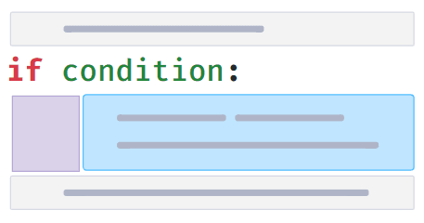

Conditional Block

Block of code which executes only if a condition is

True

is called **Conditional Block**.

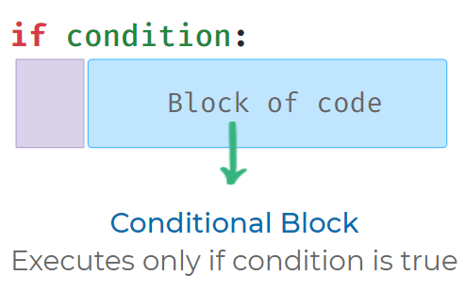

Indentation

* Space(s) in front of the conditional block is called *indentation*.
* Indentation(spacing) is used to identify Conditional Block.
* Standard practice is to use *four spaces* for indentation.

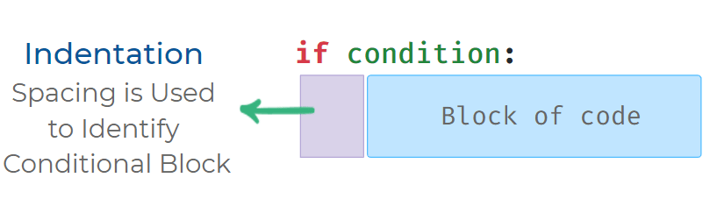

Possible Mistakes

Each statement inside a conditional block should have the same indentation (spacing).

**Wrong Code**

**

*1*

*2*

*3*

*if True:*

*print("If Block")*

*print("Inside If")*

PYTHON

**Output**



IndentationError: unexpected indent

**Correct Code**



1

2

3

if True:

print("If Block")

print("Inside If")

PYTHON

If - Else Syntax

When If - Else conditional statement is used, Else block of code executes if the condition is

False

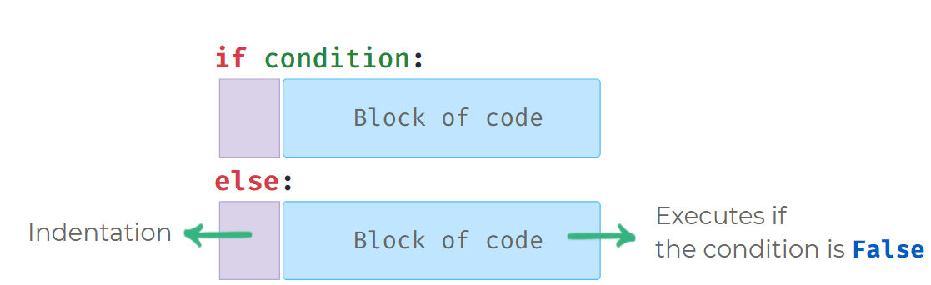

Using If-Else

**Code**



1

2

3

4

5

6

a = int(input())

if a > 0:

print("Positive")

else:

print("Not Positive")

print("End")

PYTHON

**Input**



2

**Output**



Positive

End

Possible Mistakes in If-Else

Else can only be used along with if condition. It is written below if conditional block

**Code**



1

2

3

4

5

6

if False:

print("If Block")

print("After If")

else:

print("Else Block")

print("After Else")

PYTHON

**Output**



SyntaxError: invalid syntax

SingleLineWarning

**Warning**

Note: No code is allowed in between if conditional block and else statement.

Notes

Discussions

Notes